作业一：

1、

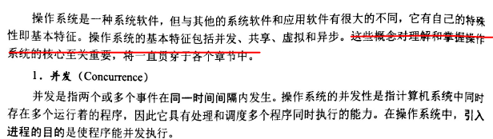

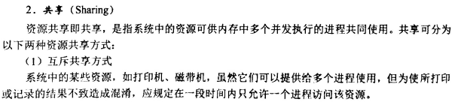

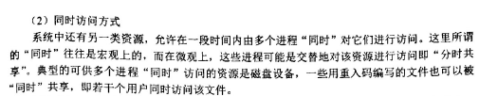

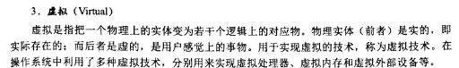

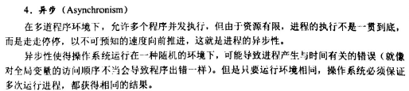

2、

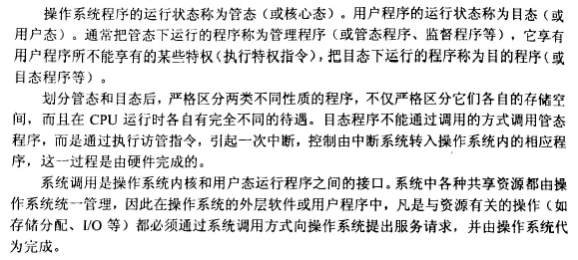

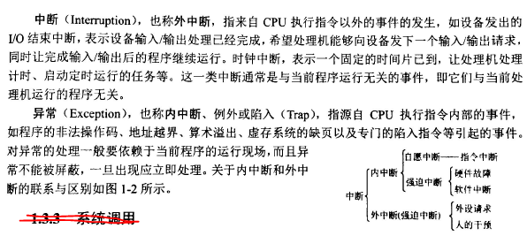

3、

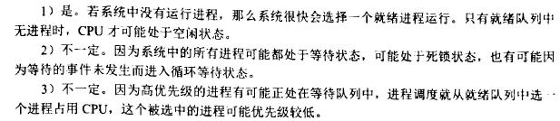

作业二：

**1.**

|  |  |  |  |  |  |  |  |
| --- | --- | --- | --- | --- | --- | --- | --- |
| 空白1 | 空白2 | 空白3 | 空白4 | 空白5 | 空白6 | 空白7 | 空白8 |
| 1 | 0 | 0 | t_mutex | t_mutex | p_mutex | p_mutex | g_mutex |

**2**

|  |  |  |  |  |  |  |
| --- | --- | --- | --- | --- | --- | --- |
| 空白1 | 空白2 | 空白3 | 空白4 | 空白5 | 空白6 | 空白7 |
| 1 | 1 | girlMutex | 1 | empty | girlCounter-- | girlMutex |

3、

